MedVoice Biotech
Sign Up and Login
Software Design Document

Gevork Asatryan
Date: 12/15/2015

TABLE OF CONTENTS
1. INTRODUCTION
1.1 Purpose
1.2 Scope
1.3 Overview
1.4 Reference Material
1.5 Definitions and Acronyms
2. SYSTEM OVERVIEW
3. SYSTEM ARCHITECTURE
3.1 Architectural Design
3.2 Decomposition Description
3.3 Design Rationale
4. DATA DESIGN
4.1 Data Description
4.2 Data Dictionary
5. COMPONENT DESIGN
6. HUMAN INTERFACE DESIGN
6.1 Overview of User Interface
6.2 Screen Images
7. REQUIREMENTS MATRIX
1. INTRODUCTION

1.1 Purpose
This design document describes the architecture of how users register and login to their Med Voice accounts.

1.2 Scope
To have a fully functioning sign up and login activity that will collect user information and store it into the MongoDB database to be used for correlation later. Along with the username and password, there will be a personal profile for each user. During registration, users will be prompted to do a digital signature agreeing to terms and conditions TBD. Facebook login will also be integrated so we can retrieve more information from users that may be used during data correlation between similar age groups, similar interests, nearby geographic locations, etc…

1.3 Overview

The Software Design Document is divided into 7 sections with various subsections.

The sections of the Software Design Document are:
- Introduction
- System Overview
- System Architecture
- Data Design
- Component Design
- Human Interface Design
- Requirements Matrix

1.4 Reference Material
http://www.tutorialspoint.com/mongodb/mongodb_php.htm
https://docs.mongodb.org/
http://www.w3schools.com/

1.5 Definitions and Acronyms

Careclient – All ordinary users (patients) who will be seeking help from Caregivers.

Caregiver – Caregivers will be the doctors, nurses and practitioners who will be offering their help to the Careclients.

CRUD – Create, Read, Update, Delete

GUI – Graphical User Interface

HTML – (HyperText Markup Language) is the standard markup language used to create web pages.

JS – (JavaScript) is the programming language of HTML and the Web.
JSON – (JavaScript Object Notation) is a lightweight data-interchange format. It is easy for humans to read and write. It is easy for machines to parse and generate.
MySQL – An open-source relational database management system (RDBMS).

MongoDB – A cross-platform document-oriented database. Classified as a NoSQL (Non-Structure Query Language) database.

Parse – To analyze a string of characters in order to associate groups of characters with the syntactic units of the underlying grammar.
Query - A database query can be either a select query or an action query. A select query is simply a data retrieval query. An action query can ask for additional operations on the data, such as insertion, updating, or deletion.

SQL – (Structured Query Language) is a special-purpose programming language designed for managing data held in a relational database management system (RDBMS).

2. SYSTEM OVERVIEW
The sign up and login activities will collect user information and store it in a database to be used for correlation later. Along with the username and password, there will be a personal profile for each user. During registration, users will be prompted to do a digital signature agreeing to terms and conditions TBD.

Facebook will be integrated and optimized for a quicker sign up feature for users who choose to not fill out a registration page all over again. The app will request authorization to collect specific health related data from the user’s Facebook profile such as the height, weight, age, and location. The users will then be able to complete a full Med Voice profile once login credentials are created within MongoDB. The more complete the users’ profiles are, the better the app will work in their favor.

3. SYSTEM ARCHITECTURE

3.1 Architectural Design

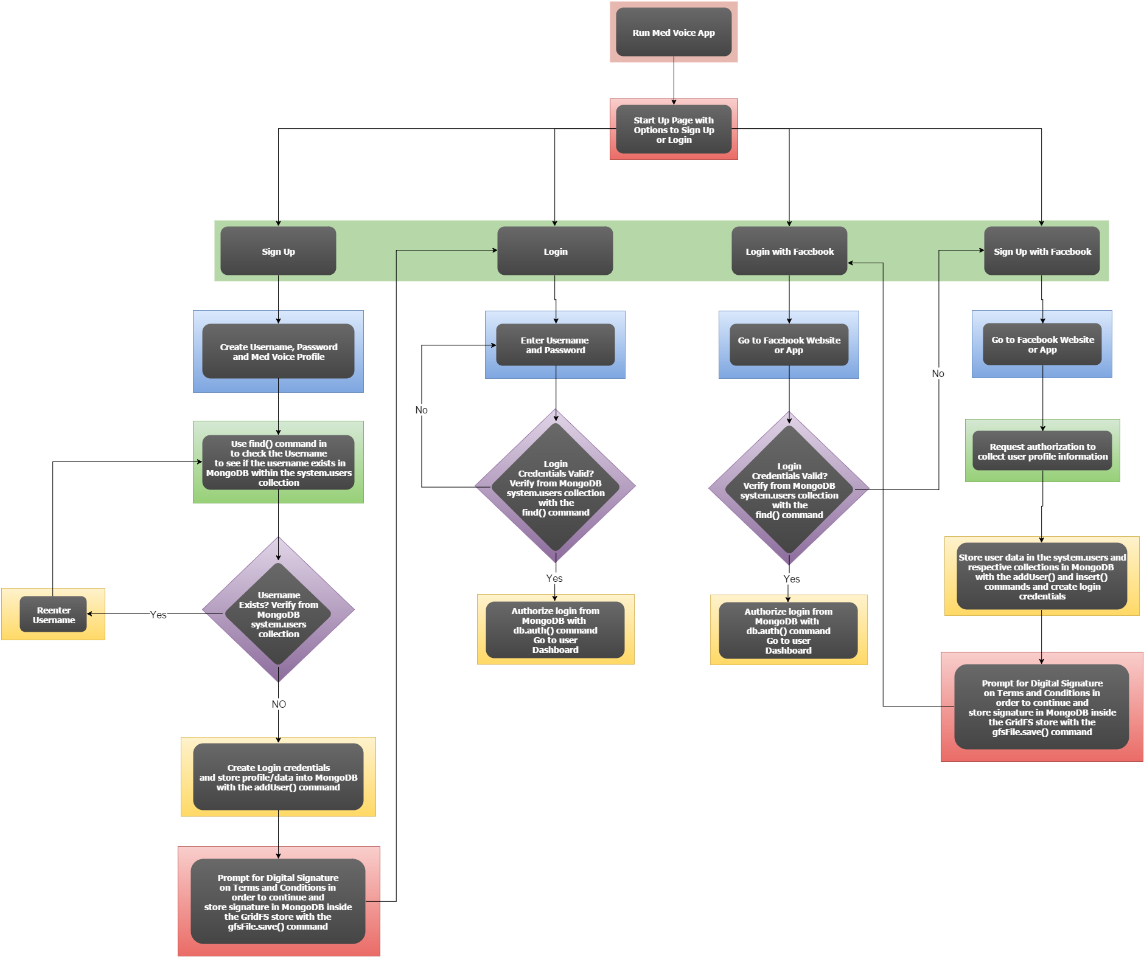

Most of the code will be done in HTML with CSS, JavaScript, and php. The main start up page will include options to Login or Sign Up. The Sign Up option will provide two separate means for a user to register for a Med Voice account. One sign up option will prompt the user to enter a username, email address, and password, while the other option would be a Facebook sign up feature that would request authorization to collect some information from the user’s Facebook profile and then create login credentials. To optimize for a quick and easy registration process, health-related questions and a full MedVoice profile will be left out of the sign up activity. Users will be able to fill that out later on. The Login option will also provide two separate means for a user to login to Med Voice and that would be with a regular sign in, as provided in the sign up process, or a Facebook login as long as the Facebook sign up has been performed prior to it.

3.2 Decomposition Description
The subsystems will make calls to the MongoDB database to add users to the system.users collection by using the addUser() command as well as storing the digital signatures used in the terms and conditions with the gfsFile.save() command. It will also verify login credentials by using the find() command to search the system.users collection for duplicate/incorrect login information.

3.3 Design Rationale

Facebook was chosen to be integrated with the app because it is one of the most widely used social media websites. Through Facebook we may request user permission to collect a wide variety of data such as user location, interests, age, contact information, etc…

Registration Design Trade-Study
Parameters | Weighted Scale | Sign Up with Full Profile |  | Sign Up with Username and Password
Sign Up Time | 25% | 7 | 1.75 | 10 | 2.5
Profile Completion | 25% | 9 | 2.25 | 1 | 0.25
User Experience | 50% | 7 | 3.5 | 10 | 5
TOTALS | 100% | 23 | 7.5 | 22 | 7.75

From the Trade Study, it is more reasonable to go with a faster and easier sign up process than it is to go with a full profile sign up. The user experience is ultimately what we need to strive for and we need to make it as pleasurable as possible.

One issue that I haven’t taken into consideration is the different types of users that we want to have: Caregivers, Careclients, and Admins. The sign up experience for different types of users would have some differences in the types of questions asked, but that would be left out of the design for now.

4. DATA DESIGN

4.1 Data Description

MongoDB has the following schema for the system.users collection
{
_id: <system defined id>,
user: "<name>",
db: "<database>",
credentials: { <authentication credentials> },
roles: [
{ role: "<role name>", db: "<database>" },
...
],
customData: <custom information>
}
Users can be admins with granted permissions to certain roles with the following:
admin.system.users.user
Permissions are specified in the roles array with the following:
admin.system.users.roles

The following is an example of a user being granted permission to specific roles and with the Zip Code added as a customerData field:

{
_id : "home.Kari",
user : "Kari",
db : "home",
credentials : {
"SCRAM-SHA-1" : {
"iterationCount" : 10000,
"salt" : nkHYXEZTTYmn+hrY994y1Q==",
"storedKey" : "wxWGN3ElQ25WbPjACeXdUmN4nNo=",
"serverKey" : "h7vBq5tACT/BtrIElY2QTm+pQzM="
}
},
roles : [
{ role: "read", db: "home" },
{ role: "readWrite", db: "test" },
{ role: "appUser", db: "myApp" }
],
customData : { zipCode: "64157" }
}

4.2 Data Dictionary
Data from the sign up activity will almost entirely be stored in the system.users collection. Other data pulled from Facebook, such as location, will be stored in a GPS collection. Signatures for Terms and Conditions will be stored in a Signatures collection. Other health related data will be stored in a Health collection.

5. COMPONENT DESIGN
Use Case
Sign up – Caregiver, Careclient, Admins
Login – Caregiver, Careclient, Admins

In this section, we take a closer look at what each component does in a more systematic way.

6. HUMAN INTERFACE DESIGN
6.1 Overview of User Interface
Describe the functionality of the system from the user’s perspective. Explain how the user will be able to use your system to complete all the expected features and the feedback information that will be displayed for the user.

6.2 Screen Images

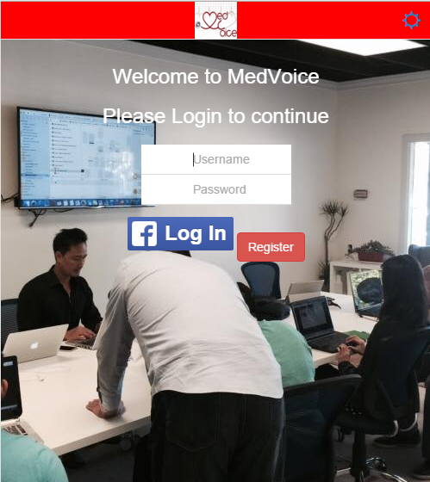
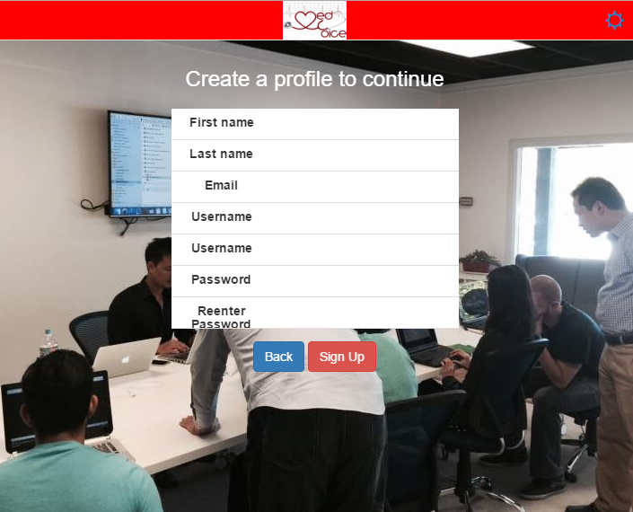

7. REQUIREMENTS MATRIX
Provide a cross reference that traces components and data structures to the requirements in your requirements document.
Use a tabular format to show which system components satisfy each of the functional requirements from the requirements document. Refer to the functional requirements by the numbers/codes that you gave them in the requirements.

